# **PART A – UML DIAGRAM**

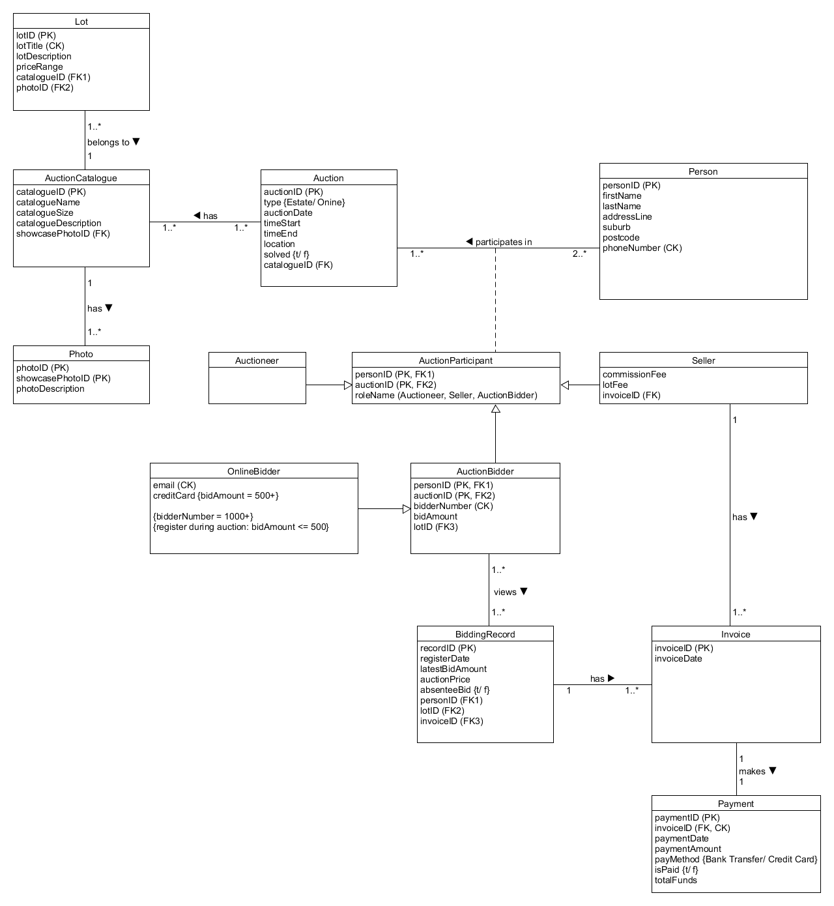

**Diagram Assumptions:**

* There are 2 types of association in this diagram which are association line used for displaying multiplicity between classes and inheritance.
* Whist, Inheritance means one class inherit all of the attributions in its parent class as it is “one kind of” the parent class. Therefore, Seller, Auction Bidder and Auctioneer are Auction Participant themselves as well as Online Bidder is one type of Auction Bidder.
* Inheritance association is an appropriate way to display the relationship between parent class and its child classes that enables subclasses to access all of the attributes inside the superclass which are the shared data among subclasses.
* There are 2 approaching ways to demonstrate an inheritance relationship among classes: vertical (share primary attributes, used in AuctionParticipant class association) and horizontal (share all attributes, used in AuctionBidder class association).
* There is an association class which assists clarify the relationship and many-to-many multiplicity of two classes by adding more supportive attributes.

# **PART B – CREATE TABLE Statement**

**Table Schemas covering:**

* **List each lot in an auction and images associated with each lot**
* **Register on-floor and online bidder**

**Auction**

Auction(auctionID, type, auctionDate, timeStart, timeEnd, location, solved, catalogueID)

PK(auctionID)

FK(catalogueID) -> AuctionCatalogue(catalogueID)

**AuctionCatalogue**

AuctionCatalogue(catalogueID, catalogueName, catalogueDescription, showcasePhotoID)

PK(catalogueID)

FK(showcasePhotoID) -> Photo(showcasePhotoID)

**Photo**

Photo(photoID, showcasePhotoID, photoDescription)

PK(photoID, showcasePhotoID)

**Lot**

Lot(lotID, lotTitle, lotDescription, priceRange, catalogueID, photoID)

PK(lotID)

CK(lotTitle)

FK1(catalogueID) -> AuctionCatalogue(catalogueID)

FK2(photoID) -> Photo(photoID)

**Person**

Person(personID, firstName, lastName, addressLine, suburb, postcode, phoneNumber)

PK(personID)

CK(phoneNumber)

**AuctionParticipant**

AuctionParticipant(auctionID, personID, roleName)

PK(auctionID, personID)

FK1(auctionID)

FK2(personID)

**AuctionBidder**

AuctionBidder(personID, bidderNumber, auctionID, bidAmount, lotID)

PK(personID, auctionID)

CK(bidderNumber)

FK1(personID) -> Person(personID)

FK2(auctionID) -> Auction(auctionID)

FK3(lotID) -> Lot(lotID)

**OnlineBidder**

OnlineBidder(bidderNumber, auctionID, personID, lotID, bidAmount, email, creditCard)

PK(personID, auctionID)

CK(email)

CHECK(bidderNumber)

CHECK(bidAmount)

FK1(personID) -> Person(personID)

FK2(auctionID) -> Auction(auctionID)

FK3(lotID) -> Lot(lotID)

# **PART C – CREATE TABLE Statements**

CREATE TABLE Auction (

auctionID INT IDENTITY NOT NULL,

type VARCHAR(100) NOT NULL,

auctionDate DATE DEFAULT GetDate(),

timeStart CONVERT(TIME, DATETIME) DEFAULT CONVERT(TIME, GETDATE()),

timeEnd TIME DEFAULT CONVERT(TIME, GETDATE()),

location VARCHAR(100) NOT NULL,

solved BIT DEFAULT ‘t’,

catalogueID INT,

CONSTRAINT Auction_PK PRIMARY KEY (auctionID),

CONSTRAINT Auction_FK FOREIGN KEY (catalogueID) REFERENCES AuctionCatelogue(catalogueID)

);

CREATE TABLE AuctionCatalogue (

catalogueID INT INDENTITY NOT NULL,

catalogueSize INT,

catalogueName VARCHAR(100) NOT NULL,

catalogueDescription VARCHAR(MAX) NOT NULL,

showcasePhotoID INT,

CONSTRAINT AuctionCatalogue_PK PRIMARY KEY (catalogueID),

CONSTRAINT AuctionCatalogue_FK FOREIGN KEY (showcasePhotoID) REFERENCES Photo(showcasePhotoID)

);

CREATE TABLE Lot (

lotID INT INDENTITY NOT NULL,

lotTitle VARCHAR(100) NOT NULL,

lotDescription VARCHAR(MAX) NOT NULL,

priceRange INT4RANGE,

catalogueID INT,

photoID INT,

CONSTRAINT Lot_PK PRIMARY KEY (lotID),

CONSTRAINT Lot_FK1 FOREIGN KEY (catalogueID) REFERENCES AuctionCatalogue(catalogueID),

CONSTRAINT Lot_FK2 FOREIGN KEY (photoID) REFERENCES Photo(photoID)

);

CREATE TABLE Photo (

photoID INT IDENTITY NOT NULL,

showcasePhotoID INT IDENTITY NOT NULL,

photoDescription VARCHAR(MAX),

CONSTRAINT Photo_PK PRIMARY KEY (photoID),

CONSTRAINT Photo_PK PRIMARY KEY (showcasePhotoID)

);

CREATE TABLE Person (

personID INT INDENTITY NOT NULL,

firstName VARCHAR(100) NOT NULL,

lastName VARCHAR(100) NOT NULL,

addressLine VARCHAR(100) NOT NULL,

suburb VARCHAR(100) NOT NULL,

postcode INT,

phoneNumber INT,

CONSTRAINT Person_PK PRIMARY KEY (personID),

);

CREATE TABLE AuctionParticipant (

personID INT,

auctionID INT,

roleName VARCHAR(100) NOT NULL,

CONSTRAINT AuctionParticipant_PK PRIMARY KEY (personID),

CONSTRAINT AuctionParticipant_PK PRIMARY KEY (auctionID),

CONSTRAINT AuctionParticipant_FK FOREIGN KEY (personID) REFERENCES Person(personID),

CONSTRAINT AuctionParticipant_FK FOREIGN KEY (auctionID) REFERENCES Auction(auctionID)

);

CREATE TABLE AuctionBidder (

bidderNumber INT INDENTITY NOT NULL,

auctionID INT,

personID INT,

lotID INT,

CONSTRAINT AuctionBidder_PK PRIMARY KEY (personID),

CONSTRAINT AuctionBidder_PK PRIMARY KEY (auctionID),

CONSTRAINT AuctionBidder_FK FOREIGN KEY (auctionID) REFERENCES Auction(auctionID),

CONSTRAINT AuctionBidder_FK FOREIGN KEY (personID) REFERENCES Auction(personID),

CONSTRAINT AuctionBidder_FK FOREIGN KEY (lotID) REFERENCES Auction(lotID)

);

CREATE TABLE OnlineBidder (

bidderNumber INT INDENTITY NOT NULL,

auctionID INT,

personID INT,

bidAmount INT,

lotID INT,

email VARCHAR(100) NOT NULL,

creditCard VARCHAR(100),

CONSTRAINT check_bidderNumber CHECK(bidderNumber > = 1000),

CONSTRAINT check_bidAmount CHECK(bidAmount > = 500),

CONSTRAINT AuctionBidder_PK PRIMARY KEY (personID),

CONSTRAINT AuctionBidder_PK PRIMARY KEY (auctionID),

CONSTRAINT AuctionBidder_FK FOREIGN KEY (auctionID) REFERENCES Auction(auctionID),

CONSTRAINT AuctionBidder_FK FOREIGN KEY (personID) REFERENCES Auction(personID),

CONSTRAINT AuctionBidder_FK FOREIGN KEY (lotID) REFERENCES Auction(lotID)